**EMERGING TRENDS IN THE BIOLOGICAL SCIENCES**

**INTRODUCTION**

Biology is the study of life and living beings, encompassing various sub-disciplines such as microbiology, botany, zoology, and physiology. Recent developments in biological sciences have seen significant advancements in our understanding of life at the molecular level, driven by powerful new technologies such as CRISPR gene editing, allowing for precise manipulation of genomes, leading to breakthroughs in fields of personalized medicine, disease treatment, and synthetic biology. New innovations are also pushing the boundaries of research in microbiome studies, regenerative medicine, and neurobiology, paving the way for potential cures to complex diseases and novel applications in agriculture and environmental science.

As the various sectors of biological sciences continue to evolve, 2025 is a pivotal year for groundbreaking innovations. From advanced gene-editing tools to AI-driven drug discovery, the boundaries of what is possible in science and technology are expanding like never before. These emerging trends not only promise to revolutionize healthcare but also have the potential to reshape various sectors such as agriculture, environmental science, and manufacturing.

In this book chapter, we explore the emerging trends that have the potential to redefine the landscape of biological sciences, offering insights into the transformative technologies and approaches driving progress in these dynamic fields. Rapid advancements in technology have revolutionized the field, providing novel tools and approaches that are reshaping our understanding of living systems. We address how these technologies have enabled unprecedented insights into cellular processes, genetic engineering, precision medicine and applications across various biological disciplines. Moreover, by embracing these emerging technologies and leveraging their potential, researchers can unlock new frontiers in biological science, driving innovation and paving the way for transformative discoveries. This chapter serves as a comprehensive guide for researchers, educators, and professionals seeking to navigate the dynamic landscape of emerging technologies and harness their power to propel biological science forward.

# **A) INNOVATIVE MICROSCOPY TOOL PROVIDES A NEW WAY TO SEE WHAT LIES BETWEEN CELLS**

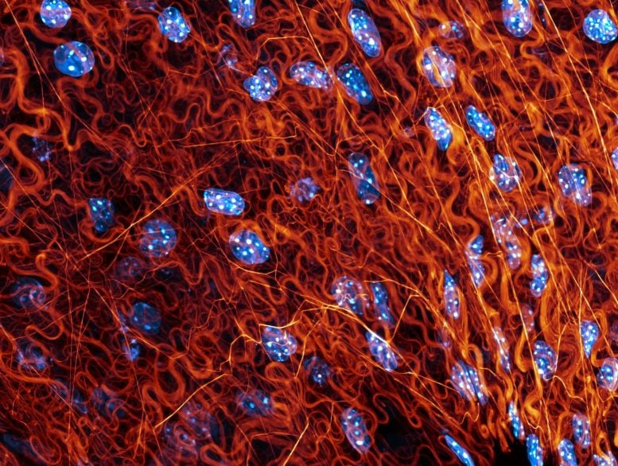

**Fig-1: Fascia of live mouse pancreas, in which the extracellular matrix is labeled with Rhobo6 (red) and nuclei are labeled with Hoechst, Credit: Fiore et al.**

**Scientists have developed Rhobo6, a light microscopy probe that reveals extracellular matrix structures in live tissues, advancing biological research and disease diagnostics.**

Rhobo6 is a light microscopy probe that selectively binds to extracellular matrix glycans, increasing its fluorescence and allowing clear visualization of these structures in live tissues. This innovative tool enables researchers to study the extracellular matrix in detail without disrupting native biological processes, offering new insights into tissue biology and disease.

The extracellular matrix supports and gives structure to our cells and tissues: It provides a scaffold for cells to grow in, dictates the mechanical properties of tissues, and supplies pathways for cells to travel.

The probe, Rhobo6 does not permeate cells and remains in the surrounding area. The molecule reversibly binds to glycans, one of the most abundant biomolecules of the extracellular matrix. Upon binding, Rhobo6 increases its fluorescence. As a result of this reversible, fluorogenic binding, we can visualize extracellular matrix structure in live tissues and animals without interfering with native biological processes. Rhobo6 can also prove useful in studying diseases linked to changes in the extracellular matrix, in diagnostic imaging, and surgical imaging of tumors in live animals. (1)

**B) ADVANCING MICROSCOPY TO CAPTURE PROTEIN ORIENTATION IN 3D**

**Scientists have developed** a hybrid microscope at the Marine Biological Laboratory (MBL), that allows simultaneous imaging of full 3D orientation and position of an variety of molecules, such as labeled proteins inside cells. The microscope combines polarized fluorescence technology, a valuable tool for measuring the orientation of molecules, with a dual-view light sheet microscope (diSPIM), which excels at imaging along the depth (axial) axis of a sample. This scope can have powerful applications. For example, proteins change their 3D orientation, typically in response to their environment, which allows them to interact with other molecules to carry out their functions. This new instrument allows one to "correct" for tilt and still capture the 3D orientation and position of the spindle molecules (microtubules). (2)

# **C) MEET APOLLO: RESEARCHERS CREATE WORLD’S LARGEST DIGITAL MICROBE COLLECTION**

Researchers at the University of Galway have developed APOLLO, the world’s largest digital collection of microbial models, comprising 247,092 computer-generated representations of bacteria from the human microbiome. This amazing resource aims to advance our understanding of how microbial communities influence health and disease. Focusing on the bacterial microbiome, the diverse populations of bacteria that live in and on the human body, APOLLO provides detailed models of each microbe’s metabolic processes.

By enabling scientists to study microbial functions through computational simulations rather than relying solely on complex lab experiments, this database has the potential to accelerate medical discoveries and improve disease research. Spanning multiple continents, age groups and body sites, APOLLO is the most extensive computational model collection of the human microbiome created to date.

#### **Simulating Real-World Microbiome Communities**

The team also created over 14,000 computer simulations of individual microbiome communities, based on real-life samples, to reveal how microbial metabolism varies by body site, age, and health conditions. The APOLLO simulations also predicted key faecal metabolites linked to Crohn’s disease and Parkinson’s disease insights that could help shape future diagnostic and treatment strategies.

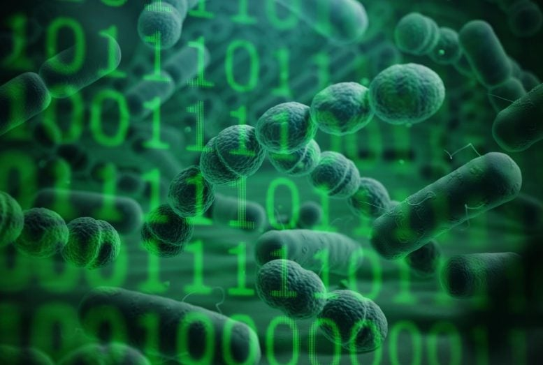

**Fig-2: APOLLO, the world’s largest collection of digital microbe models, Credit: University of Galway**

#### **How APOLLO will benefit society:**

* Improved diagnostics – by identifying microbial metabolic markers, APOLLO could help develop non-invasive diagnostic tools, allowing earlier and more accurate diagnosis.
* Personalized treatments – simulations can predict how an individual’s microbiome interacts with their diet, medications, and health conditions. This could lead to tailored treatments that optimize gut health and improve responses to therapies.
* Drug development and probiotics – it may be possible to design targeted probiotics, prebiotics, and microbiome-based therapies to treat specific diseases more effectively.
* Public Health insights – by including diverse microbiomes, APOLLO provides a global perspective, helping address how modern lifestyles impact microbiome health. This knowledge shall guide public health policies, such as around antibiotic use, diet, and disease prevention.

**D) NEW ANTIBIOTIC DESIGN COULD END THE ARMS RACE WITH RESISTANT BACTERIA**

About 35,000 people in the U.S. die each year from antibiotic-resistant bacterial infections caused by pathogens like *Staphylococcus*, while about 2.8 million people suffer from bacteria-related illnesses. **Scientists have** designed a new family of antibiotics, a variation of an existing drug called vancomycin used as a last resort for extremely ill patients. The new version of vancomycin targets, bonds to and renders inactive two different parts of a molecule present on the surface of pathogenic bacteria. This new version of vancomycin could be a giant leap forward for medicine. By binding molecules that bacteria need to build a protective cell wall, the drug may help end the arms race between antibiotic and bacteria and eliminate the need for researchers to continuously design new drugs antibiotic-resistant bacteria. (4)

# **E) A NEWLY DISCOVERED TYPE OF STEM CELL COULD ALLOW SCIENTISTS TO MAKE ORGANS IN A DISH**

Traditionally, researchers create stem cells by placing an embryo in a dish or employing molecules found in pluripotent cells to reprogram differentiated cells and create induced pluripotent cells. This emerging study explores other possibilities. Researchers have utilized a mouse model to discover an alternate path that some cells follow to build organs and used that information to exploit a new kind of stem cell as a possible supply of organs in a dish. For many years, researchers have worked to duplicate the process by which embryonic stem cells develop into organs and other parts of the body. However, despite several attempts, The maturation of these lab-grown cells has proven to be quite challenging.



**Fig-3: Stem Cells, Credit: Padilla, Credit: M. S. T. L., & Nowick, J. S**

#### **Alternative Route Using Extra-Embryonic Stem Cells**

The study focused on pluripotent stem cells and endoderm extra-embryonic stem cells. They help the gastrointestinal organs by acting as key support cells that supply membranes, nourishment for the membranes, and other functions. The researchers identified all the potential cells that were candidates to form organs associated with the digestive tract, such as the liver, pancreas, lung, and intestine, by labelling them with a genetic marker. (5)

# **F)SCIENTISTS USE TASAR SILKWORM TO HELP GROW ARTIFICIAL CARDIAC TISSUE**

Scientists at MPI for Heart and Lung Research are trying to repair damaged cardiac tissue by growing replacement tissue in a laboratory. Researchers have created a three-dimensional scaffold by using the silk produced by a tropical silkworm upon which they were able to load cardiac muscle cells. The hope is that this research will lead to artificial cardiac tissue that will restore complete cardiac function in people suffering from heart muscle damage.

# scientists use silk from the tasar silkworm as a scaffold for heart tissue

**Fig-3: Disks cut from the cocoon of the tasar silkworm grub provide a basic scaffold for heart muscle cells.**

**Credit: MPI for Heart and Lung Research**

Damaged heart muscle cannot be regenerated. Scar tissue grows in place of the damaged muscle cells. Scientists are seeking to restore complete cardiac function with the help of artificial cardiac tissue. They have succeeded in loading cardiac muscle cells onto a three-dimensional scaffold, created using the silk produced by a tropical silkworm.

Of all the body’s organs, the heart is probably the one most well known for performance and efficiency. Decade after decade, it continues to pump blood around our bodies. However, this performance optimization comes at a high price: throughout evolution, almost all of the body’s regeneration mechanisms in the heart have become deactivated. As a result, a heart attack is a very serious event for patients; dead cardiac cells are lost forever. The consequence is the heart losing its pumping power and deterioration of the patient’s quality of life. In their attempt to develop a treatment for the repair of cardiac tissue, scientists are pursuing the aim of growing replacement tissue in the laboratory, which could then be used to produce replacement patches for the repair of damaged cardiac muscle. At the university, coin-sized disks are being produced from the cocoon of the tasar silkworm *(Antheraea mylitta*). The fiber produced by the tasar silkworm displays several advantages over other substances tested. “The surface has protein structures that facilitate the adhesion of heart muscle cells. It’s also coarser than other silk fibers which is why the muscle cells grow well on it and can form a three-dimensional tissue structure. (6)

# **G) DNA ORIGAMI SUGGESTS ROUTE TO REUSABLE, MULTIFUNCTIONAL BIOSENSORS**

Using an approach called DNA origami, scientists have developed a technique that could lead to cheaper, reusable biomarker sensors for quickly detecting proteins in bodily fluids, eliminating the need to send samples out to lab centers for testing.

DNA origami enables long strands of DNA to fold, through self-assembly, into any desired shape. They begin with a long strand of DNA and the scaffold in solution. Because the nucleotide which form DNA bind in a known way (adenine binds to thymine, and guanine binds to cytosine), the scientists can add hundreds of short sequences of complementary DNA knowing they will bind to the scaffold on either end at known locations. Those short, added pieces of DNA fold the scaffold and give it shape, acting as "staples" that hold the structure together. The technique can then be used to create shapes ranging from maps of continents to nanoscale transistors. Scientists even used DNA origami to create a lilypad-like structure - a flat, circular surface about 100 nanometers in diameter, tethered by a DNA linker to a gold electrode. Both the lilypad and the electrode have short DNA strands available to bind with an analyte, a molecule of interest in solution -- whether that be a molecule of DNA, a protein, or an antibody. When the analyte binds to those short strands, the lilypad gets pulled down to the gold surface, bringing 70 reporter molecules on the lilypad (which indicate that the targeted molecule is present) into contact with the gold surface. These reporters are redox reactive molecules, meaning they can easily lose electrons during a reaction. So, when they get sufficiently close to an electrode, an electric current can be observed. A stronger current indicates that more of the molecule of interest is present.

The relatively large size of the lilypad origami also means that the system can readily accommodate and detect larger molecules, such as large proteins. In the new paper, the team showed that the two short DNA strands on the lilypad and the gold surface could be used as adapters, making it a sensor for proteins rather than for DNA. In the work, the researchers added the vitamin biotin to those short DNA strands to turn the system into a sensor for the protein streptavidin. Then they added a DNA aptamer, a DNA strand that can bind to a specific protein; in this case, they used an aptamer that binds to a protein called platelet-derived growth factor BB (PDGF-BB), which could be used to help diagnose diseases such as cirrhosis and inflammatory bowel disease. (7)

**H) BREAKTHROUGH METHOD OPENS DOOR TO FLUORINATED OXETANE DRUG MOLECULES**

Researchers from the National University of Singapore (NUS) have pioneered a new catalytic transformation that converts epoxides into fluorinated oxetanes, a coveted but difficult-to-make class of drug molecules that escaped synthetic preparation for years. By unlocking a brand new pathway to these valuable drug scaffolds, this discovery potentially opens the door to new medicines for drug discovery applications.

## **A novel method to synthesize fluorinated oxetanes**

The researchers deviated from the standard logic of synthesis by designing a new strategy that inserts a difluorocarbene species selectively into the structure of readily available three-membered epoxides. This process is facilitated by an inexpensive copper catalyst, which stabilises the difluorocarbene generated from a commercially available organofluorine precursor. The resulting copper difluorocarbenoid complex coordinates with the epoxide and triggers site-selective ring cleavage and cyclisation, to yield the desired α,α-difluoro-oxetane product via a metallacycle intermediate. Computational studies by Prof Liu's group provided insight into the new reactivity mode and its underlying mechanism. Additionally, lipophilicity and metabolic stability studies performed by Prof Chan's team supported the potential of these fluorinated oxetanes as valuable drug scaffolds.

To demonstrate the practical utility of their method, the researchers successfully synthesized fluorine-containing analogues of oxetane, β-lactone and carbonyl pharmacophores commonly found in a variety of biologically active compounds. Computed electrostatic potential maps of isosteric oxetane, αα-difluoro-oxetane and β-lactone further indicated the potential of these compounds to serve as analogues of each other. Studies are ongoing to investigate the biological properties of these newly synthesized drug analogues and extend the methodology to other classes of heterocyclic drug-like compounds. (8)

**I) INHALABLE BIOHYBRID MICROROBOTS: A NON-INVASIVE APPROACH FOR LUNG TREATMENT**

Due to the rising prevalence of respiratory diseases, effective lung treatment modalities are an important area of research. Current drug delivery systems face limitations that impede their efficacy and therapeutic outcomes.  Biohybrid microrobots show promise for active in-vivo drug delivery, especially for pulmonary applications. Depending on the organ or disease site being targeted, the microrobots are tailored for specific functionalities and enhancing therapeutic outcomes.  Inhalation-based drug delivery is a highly attractive approach for treating lung diseases. [9]

Drug carriers can significantly enhance therapeutic efficacy by stabilizing active agents, increasing bioavailability, and facilitating targeted and controlled release directly to the affected pulmonary tissues. Various materials like polymeric nanoparticles, liposomes, lipid nanoparticles, or micelles, can be used as carriers for inhalation-based treatment of lung diseases. [10]Biohybrid microrobots, relying offer significant advantages over their synthetic counterparts as there is no problem of limited fuel availability, restricted access to specific organs and tissues, and potential toxicity. The inhalable microrobot-based lung delivery system relies on the green algae *Micromonas pusilla.* The small size of the algae robots (approximately 1–1.5 μm in diameter), enables them to be effectively encapsulated within aerosol particles, smaller than 10 μm facilitating optimal inhalation into the lungs.

*M. pusilla* was cultivated in L1-Si medium and maintained in a 22 °C thermostatic incubator. A nebulizer encapsulates picoeukaryote algae microrobots within small aerosol particles, enabling them to reach the lower respiratory tract. The algae robots were transferred into PBS and aerosolized using a jet nebulizer system that generated a stable aerosol flow. Therapeutic efficacy was tested in a mouse model of acute methicillin-resistant *Staphylococcus aureus* pneumonia.

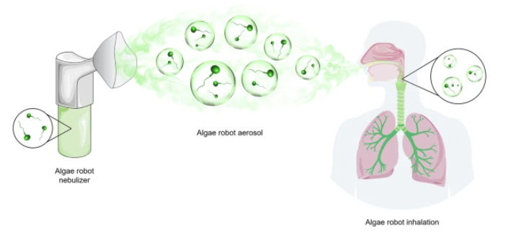

**Fig-4: Nebulization of M. pusilla green algae-based biohybrid microrobots, Credit: Li, Z., Guo, Z., Zhang, F. et al**

The algae robots exhibited negligible cytotoxicity in vitro and during the 60-minute nebulization period, the mice who inhaled these algae robots remained active and exhibited no signs of respiratory distress or discomfort which proved the user-friendly nature of these algae robots. Vancomycin a commonly used antibiotic for treating MRSA infections, was encapsulated within platelet membrane-coated PLGA nanoparticles. the amount of loaded drug increased proportionally with the increase of algae number. The amount of loaded drug increased proportionally with the increase of algae number visualisd by TEM.

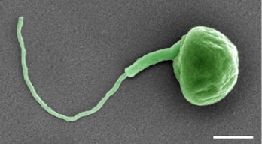

**Fig-5: Algae Microrobots Visualised, Credit: Li, Z., Guo, Z., Zhang, F. et al**

Further study of minimal inhibitory concentration (MIC) against MRSA showed that bacterial growth was inhibited at a Vancomycin concentration of 2 μg mL−1. Further enumeration of bacterial colony-forming units (CFU) demonstrated and proved that 2 μg mL−1 Vanc was also the minimal bactericidal concentration (MBC) against MRSA. An evaluation of the biosafety of the algae-based biohybrid microrobot nebulizer system illustrated that this non-invasive method had negligible impact on blood chemistry, blood cell counts, and organ integrity, underscoring its potential suitability towards clinical transition. Further studies will be needed in larger animal models to validate safety and therapeutic efficacy when delivering the aerosols via a mouthpiece or mask versus the chamber-based approach used in the present work. Scaling this administration method for human use will require researchers to account for the differences in lung structure and size, towards maintaining the efficient distribution and retention we achieved here in murine models. [11]

**J) AI AND MACHINE LEARNING IN DRUG DISCOVERY AND DEVELOPMENT**

To advance drug discovery, researchers have applied various AI tools to predict the efficacy and toxicity of drug compounds and have identified potential drug candidates for further investigation. To date, several biotechnology and pharmaceutical companies have reported using AI for their drug discovery projects, such as Iktos, BioXcel Therapeutics, Datafoundry, and Sanofi.

During the initial stages of many drug discovery projects, medicinal chemistry methods are used to examine large numbers of potential drug compounds to identify those with desired properties. These studies are often labor intensive, expensive, and limited by the availability of test compounds and biological systems capable of predicting their potential behavior in the body.

While traditional methods of pharmaceutical research have been relatively successful in the past, they are limited by their reliance on trial-and-error experimentation and their inability to accurately predict the behavior of new potential bioactive compounds.”

In an effort to overcome these challenges, researchers have constructed numerous AI algorithms based on available data to predict the efficacy and toxicity of new drug compounds. These algorithms can also be used to identify novel drug targets, such as specific proteins or genetic targets involved in diseases of interest. This trend is something that will only continue to evolve at a rapid pace in 2025.

**K) SYNTHETIC BIOLOGY AND ADVANCED BIOMANUFACTURING**

Synthetic biology enables the design and construction of complex biological systems simplified through engineering. Synthetic biology is revolutionizing the way we create materials, manufacture goods, and develop novel therapeutics. By leveraging the principles of biology and engineering, this field is enabling the production of bio-based materials and sustainable alternatives to traditional chemical manufacturing, aligning with global efforts to reduce environmental impact.

One of the most transformative tools in synthetic biology is CRISPR (Clustered Regularly Interspaced Short Palindromic Repeats), which has advanced from a precise gene-editing tool to a versatile platform for programmable biological systems. CRISPR technology is now being used to reprogram microorganisms to produce biofuels, biodegradable plastics, and high-value chemicals in a more sustainable way than conventional processes.

The integration of synthetic biology and biomanufacturing has accelerated the personalized medicines. Engineered microbes and cell lines now can produce therapeutic proteins, enzymes, and vaccines at large scale with high precision. Additionally, advances in metabolic engineering and synthetic genomes allow scientists to redesign entire metabolic pathways to optimize production yields, making bio-based solutions commercially viable.

Programmable biological systems are taking this field even further by allowing researchers to create living systems which can adapt to environmental conditions or deliver therapeutics in a controlled manner. For example, engineered bacteria capable of detecting and neutralizing pathogens in real-time can provide innovative treatments for infectious diseases. As synthetic biology continues to mature, its applications in biomanufacturing will lead to a more sustainable and efficient future, from creating next-generation biomaterials to transforming how we address global health challenges.

**L)** **PERSONALIZED MEDICINE AND GENOMICS – AM EMERGING TREND**

Personalized medicine is rapidly transforming healthcare by tailoring treatment plans to the unique genetic makeup of each individual. Powered by pioneer studies in genomics and molecular diagnostics, this trend is driving precision medicine into mainstream clinical applications, offering unprecedented potential to improve outcomes and reduce side effects.

Advancements in genome sequencing technologies have made it faster and more affordable to decode an individual’s DNA. These innovations enable clinicians to identify genetic mutations associated with specific diseases, especially in oncology, where targeted therapies are now designed to inhibit cancer growth based on a tumor's unique genetic profile. For example, liquid biopsies and companion diagnostics are reimagining cancer care by enabling non-invasive, real-time monitoring of disease progression and treatment effectiveness.

The impact of genomics extends beyond cancer, with significant breakthroughs in diagnosing and managing rare genetic disorders. Whole-genome sequencing and targeted molecular tools are helping uncover the genetic underpinnings of conditions that were previously difficult to diagnose, paving the way for new therapeutic strategies. As genomics continues to evolve, personalized medicine holds the promise of transforming disease management across a wide range of applications.

**M) LATEST ADVANCES IN CELL AND GENE THERAPIES**

Cell and gene therapies are at the forefront of biomedical innovation, offering groundbreaking treatments for previously untreatable conditions. From CAR-T cell therapies targeting blood cancers to emerging applications in solid tumors, these therapies are redefining the landscape of modern medicine.

Stem cell research has gained momentum, enabling regenerative approaches for damaged tissues and chronic conditions. Innovations such as induced pluripotent stem cells (iPSCs) are opening up new possibilities for developing personalized cell-based treatments and modeling diseases in vitro for drug discovery.

Despite these breakthroughs, challenges are inevitable. The high costs associated with developing and delivering cell and gene therapies limit accessibility for many patients. Scalability and manufacturing hurdles and ensuring viability of therapeutic cells during production are compelling issues that the industry needs to address. Furthermore, the evolving regulatory landscape aims to balance innovation with patient safety, ensuring these transformative therapies reach those in need.

As the field matures, continued investment in manufacturing technologies and regulatory frameworks will be critical to overcoming these obstacles and broadening the reach of cell and gene therapies.

**N) SUSTAINABILITY AND GREEN BIOTECH SOLUTIONS –** **A BIO-BASED INNOVATION**

Biotechnology is playing a pivotal role in addressing some of the most pressing environmental challenges of our time. From creating carbon capture technologies to developing biofuels, green biotech solutions are paving the way for a more sustainable future.

In the energy sector, bio-based innovations are reducing reliance on fossil fuels. For instance, engineered microbes are being used to produce renewable biofuels and biodegradable plastics, minimizing carbon emissions and plastic waste. Similarly, advances in synthetic biology enable efficient carbon capture systems, wherein microbes sequester CO₂ and transform it into valuable materials.

Agriculture is also benefiting from green biotech. Eco-friendly solutions such as genetically modified crops with enhanced resistance to pests and drought are reducing the need for chemical pesticides and water-intensive farming practices. Bioremediation solutions, which use organisms to clean up environmental pollutants, are further supporting efforts in waste management and soil restoration.

By integrating biotechnology into industrial and agricultural systems, sustainability-focused biotech companies are creating innovative products and processes that balance economic growth with environmental stewardship. These advancements position biotechnology as a cornerstone of a greener, more resilient future.

**O) CRISPR THERAPEUTICS PIPELINE GAINING MOMENTUM**

Cutting-edge gene editing technologies, particularly CRISPR, are revolutionizing the landscape of drug discovery. [Casgevy](https://www.fda.gov/news-events/press-announcements/fda-approves-first-gene-therapies-treat-patients-sickle-cell-disease" \t "_blank) was the first therapy to be approved by the U.S. FDA that was developed using [CRISPR-Cas9](https://www.cas.org/resources/cas-insights/scientific-breakthroughs-2024-emerging-trends-watch) gene-editing technology, and [many new CRISPR-based therapies targeting a broad range of diseases](https://innovativegenomics.org/news/crispr-clinical-trials-2024/) have entered drug discovery pipelines and trials since.

The rapid development of [base editing](https://link.springer.com/article/10.1007/s11427-024-2699-5), [prime editing](https://news.mit.edu/2024/scientists-develop-rapid-gene-editing-screen-effects-cancer-mutations-0312), and even CRISPR-based [epigenetic modulation](https://academic.oup.com/nar/advance-article/doi/10.1093/nar/gkae1039/7893324) has propelled CRISPR to the forefront of drug discovery, with potential applications in oncology, genetic disorders, viral infections, and autoimmune diseases. Correcting mutations, silencing harmful genes, or introducing protective changes in cells marks a paradigm shift from symptom management to therapies with curative potential for patients.

A few examples of how CRISPR is enhancing therapeutic approaches include:

* Knocking out genes that inhibit T-cell function or enhance their ability to target cancer cells, leading to [more potent and less toxic CAR-T therapies](https://biomarkerres.biomedcentral.com/articles/10.1186/s40364-024-00602-z).
* Adding controllable safety switches that [can stop and reverse](https://ashpublications.org/blood/article/144/Supplement%201/3433/533162/Engineering-a-Controllable-and-Reversible-Switch) CAR-T cell therapies based on individual genetic responses.
* Identifying genes and proteins in cancer cells, revealing [new targets for PROTACs](https://www.frontiersin.org/journals/genetics/articles/10.3389/fgene.2024.1434002/full).

CRISPR’s versatility as a gene-editing tool allows for gene correction and silencing, holding potential for curative treatments. However, it’s the complementary nature of these technologies—CRISPR, CAR-T, and PROTACs—that is most exciting, enabling collaborative drug discovery across multiple technologies. New therapies that rely on CRISPR’s flexibility can address previously elusive aspects of disease biology and patient needs, shaping a future where combination approaches will yield more effective therapies.

**P) MOLECULAR EDITING BOOSTING INNOVATION IN DRUG DISCOVERY**

Traditionally, chemists have relied on a large bounded set of known reactions to synthesize complex organic molecules. However, emerging synthetic approaches are making new molecular scaffolds and shapes more accessible, potentially bringing about an [exciting new wave](https://pubs.acs.org/doi/10.1021/acs.jmedchem.4c01347) of innovation in organic and medicinal chemistry.

[Molecular editing](https://pubs.rsc.org/en/content/articlelanding/2022/qo/d2qo00043a) is a technique that allows for precise modification of a molecule’s structure by inserting, deleting, or exchanging atoms within its core scaffold. Unlike the traditional approach of building up new large molecules by assembling smaller parts through a series of stepwise reactions, molecular editing enables chemists to create new molecules by precisely modifying existing large molecules. This empowers the creation of new compounds more efficiently and cost-effectively, and by reducing the total synthetic steps, decreasing the volume of toxic solvents and energy requirements for many transformations.

Potentially the most compelling aspect of molecular editing is its anticipated positive impact on innovation. Causes and remedies for a perceived “[innovation crisis](https://link.springer.com/article/10.1007/s43546-021-00163-5)” in the pharma industry have been debated over the past decade. However, there is little question that multiplying the paths chemists have at their disposal to reach a desired structure is key to increasing the volume and diversity of molecular frameworks being considered for drug candidates, fertilizers, materials, and many other applications.

In combination with emerging AI-based synthetic applications that are already helping chemists identify and prioritize synthetic pathways, these new synthetic approaches could drive a multi-fold increase in chemical innovation over the next decade.

**Q) WASTE MANAGEMENT INNOVATIONS ADVANCING THE CIRCULAR ECONOMY**

The UN [Global Waste Management Outlook](https://www.unep.org/resources/global-waste-management-outlook-2024) for 2024 estimates that, without radical change, the combined annual waste management costs will double by 2050. As such, new technologies are advancing progress within a circular economy where reuse and recycling take on larger roles

Besides traditional recycling methods like pyrometallurgy and hydrometallurgy, new battery recycling methods are being developed that reuse valuable metals like lithium, nickel, aluminum, iron, and manganese with methods such as bioleaching, direct recycling, and electro-hydrometallurgical processes. These new approaches not only keep dangerous chemicals from [entering the environment](https://www.sciencedirect.com/topics/engineering/battery-recycling#:~:text=Because%20of%20the%20harmful%20compounds,to%20ecosystems%20and%20human%20health.), but also recapture valuable, often scarce elements used in many popular technologies.

* Biomass conversion technologies such as hydrothermal carbonization are being used to convert waste-to-energy, turning wet biomass, organic waste, and agricultural residues into [hydrochar](https://www.mdpi.com/2073-4344/11/8/939" \t "_blank), a carbon-rich material used in electricity generation and soil conditioning, and [biochar](https://climate.mit.edu/explainers/biochar), a material used for soil improvement.
* Plastic-eating bacteria are [improving the efficiency](https://www.sciencedaily.com/releases/2023/11/231101134747.htm) of [plastic recycling](https://www.nature.com/articles/s41587-024-02401-1) by regenerating monomers from waste—spurred on by the discovery of *Ideonella sakaiensis* 201-F6, a bacterium with the enzymes *Is*PETase and *Is*MHETase that break down polyethylene terephthalate (PET) into its two environmentally benign monomers, ethylene glycol and terephthalic acid. If this technology can be scaled, it will help keep up with the world’s ongoing “[addiction to plastic](https://about.bnef.com/blog/the-worlds-addiction-to-plastic-in-five-charts/).”

New, innovative efforts like these don’t just offset the costs of waste disposal but provide better financial incentives as new technologies come online. Keep an eye on technologies that can recover or create new valuable resources from waste as manufacturers, energy producers, governments, and waste management companies invest in innovation aimed at making waste management less expensive to enhance sustainability and improve the profitability of manufacturing processes.

**R) QUANTUM COMPUTING GETTING PRACTICAL**

The United Nations [has proclaimed 2025](https://quantum2025.org/en/) the International Year of Quantum Science and Technology (IYQ). While quantum computing technology isn’t yet widely commercialized, it’s making steady progress toward real-world application in scientific R&D. For example, Cleveland Clinic and IBM have recently [installed](https://newsroom.clevelandclinic.org/2023/03/20/cleveland-clinic-and-ibm-unveil-first-quantum-computer-dedicated-to-healthcare-research) the world’s first quantum computer dedicated to healthcare research and are beginning to apply its capabilities to tackle [drug discovery](https://my.clevelandclinic.org/research/computational-life-sciences/discovery-accelerator/our-projects) questions that even modern supercomputers could not answer. Researchers are exploring how quantum computing will accelerate drug discovery by enabling more complex simulations of molecule behaviors and efficient modeling of protein folding. This creates an opportunity for quantum computing to drive significant progress in a short period as implementation ramps up.

Beyond drug development, quantum computing could solve complex challenges in other fields of biology. For example, agriculture researchers are testing applications in fertilizer calculations and field monitoring that could [optimize crop yields](https://www.sciencedirect.com/science/article/abs/pii/S0168169924000711#preview-section-introduction) to enhance food production while minimizing environmental damage. Quantum computing is also anticipated to enable more accurate weather forecasting by identifying patterns within the large volume of global data and more quickly evaluate multiple disparate scenarios generated by different models.

An [announcement by Microsoft and Atom Computing](https://techcrunch.com/2024/11/19/microsoft-and-atom-computing-will-launch-a-commercial-quantum-computer-in-2025/) to deliver commercially available quantum computers in 2025, shows how rapidly the technology is advancing. While we don’t anticipate it will dominate the technology landscape in the next few years, as there are still many challenges to scaling this technology, quantum computing is emerging as a key driver in several fields.  (12)

**S) BIOREMEDIATION OF METHYLMERCURY POLLUTION**

Mercury is a highly toxic trace metal that readily biomagnifies in food webs where it is inaccessible to current bioremediation methods. It exists in various forms, including elemental mercury, inorganic mercury, and organomercurial compounds such as methylmercury. [13]

Methyl Mercury poses the greatest environmental risk to aquatic ecosystems. When ingested, Methyl Mercury is readily absorbed in the animal GIT, and Methyl Mercury assimilation typically exceeds 80%. Once in the body, methylmercury is poorly excreted, and can easily cross the blood-brain barrier and the placenta. Methyl Mercury is a potent neurotoxin and can impact the cardiovascular, reproductive, and immune systems. [14)

Scientists have found an effective new way to clean up this methylmercury.  Animals can be engineered to detoxify mercury to clean up impacted ecosystems. The research conducted by these scientists demonstrate that invertebrates like *Drosophila melanogaster* and vertebrates like *Danio rerio* can express organomercurial lyase (MerB) and mercuric reductase (MerA) obtained from *Escherichia coli* to demethylate methylmercury and remove it from their biomass as volatile elemental mercury. This research aimed at showing that animals could not only be engineered to protect themselves from toxins like methylmercury, but also remove it from the environment. The engineered animals could also tolerate higher exposures to methylmercury compared to controls.

The MerB enzyme catalyzes the conversion of methylmercury into less toxic forms, while MerA reduces it to elemental mercury, which is volatile and can be released into the atmosphere. This enzymatic detoxification process is crucial for mitigating the harmful effects of methylmercury in contaminated environments. These results demonstrate the potential of using engineered animals, including vertebrates, to express microbial enzymes for bioremediation.

Heterologous E. coli MerA and MerB were expressed in zebrafish to explore mercury bioremediation in vertebrates. After embryo microinjection, plasmids were integrated randomly into the zebrafish genome by Tol2 transposase-mediated integration. Larvae were screened for cyan fluorescent protein (CFP) in the eyes and transgenic lines were established. Some fish were engineered to express empty dual expression vectors without MerA or MerB genes (Fish/Empty Vector) as control.

After 6 days of being grown in the same glass DuranTM bottle and being fed cornmeal diet spiked with MeHG, the total average mercury concentration in the control was measured to be 5.2 μg/g (similar to the highest mercury concentrations in wild-caught sharks). The total average mercury concentration in the transgenic fish was measured to be 1.9 μg/g, 64% lower than controls.

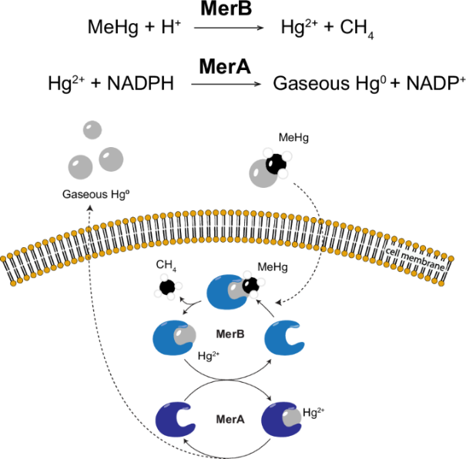

**Fig-6: Enzymatic Bioremediation of Methylmercury, Credit: Tepper, K., King, J., Manuneedhi Cholan, P. et al.**

Reducing Hg2+ to volatile Hg0 and expanding these capabilities to vertebrates opens doors to new opportunities aimed at reducing the total mercury content of a polluted site, facilitating extraction and collection of mercury from contaminated waste streams and protecting higher trophic levels from mercury toxicity by disrupting its biomagnification. Future work in other species more suitable for use in the field will require a comprehensive evaluation of their ability to extract methylmercury from a variety of contaminated dietary sources. [15]

**T) OMNIOMICS: THE NEXT SINGLE-CELL REVOLUTION**

Investment in new single-cell analysis technologies [has exploded](https://link.springer.com/article/10.1007/s00216-023-04759-8) in recent years, and these techniques are now being applied to advance critical progress in early disease detection, prenatal screening tests, biomarker testing, liquid biopsies, and biologic drug development. The market for single-cell analysis technologies related to genomics, transcriptomics, and proteomics was estimated at USD 4.34 billion in 2023 and is [projected to grow](https://www.grandviewresearch.com/industry-analysis/single-cell-analysis-market) at a CAGR of 18.7% from 2024 to 2030.

The next frontier ramping up in single-cell research is multi-omics. By combining multiple single-cell techniques, multi-omic approaches provide a more complete picture for researchers and clinicians:

* In terms of [drug discovery](https://academic.oup.com/nsr/article/10/9/nwad161/7186939), multi-omics can assist in the design of therapeutics and advance vaccine development as simultaneous integration of various single-modality omics methods at the single-cell level can help us understand various biological processes, pathways, and disease mechanisms.
* Multi-omics is also being used to establish cellular linkage trees, which make it possible for [cancer researchers](https://www.nature.com/articles/s41580-023-00615-w#Sec12) to study the impacts of epigenetic effects and genetic mutations simultaneously at the single-cell level.
* In glioblastoma patient models, multi-omics has [shown](https://www.nature.com/articles/s41698-022-00294-4) potential to improve understanding of intratumor heterogenicity, thereby informing patient-specific therapies.

Beyond multi-omics, [omniomics](https://www.nature.com/articles/s12276-024-01186-2?fromPaywallRec=false" \t "_blank) strives to merge all omics data to give us an integrated picture of human biology at the cellular level, uncovering complex biological interactions and disease mechanisms with greater accuracy. This approach has widespread applications for drug innovation and could accelerate the development of targeted therapies. It also has profound implications for improving [precision medicine](https://www.cell.com/trends/cancer/abstract/S2405-8033(21)00021-2?dgcid=raven_jbs_etoc_email), providing a deeper understanding of different cells within a tumor and how they change over time, thus paving the way for personalized therapeutic strategies. (16)

‍**CONCLUSION**

The biological science industries are poised for transformative growth in current year, driven by cutting-edge advancements in synthetic biology, personalized medicine, and cell and gene therapies. As breakthroughs in genomics and biomanufacturing converge with the urgent need for sustainable solutions, the potential to improve human health and address global challenges has never been greater.

While innovations like precision medicine and regenerative therapies promise to redefine patient care, they also underscore critical challenges, including accessibility, scalability, and ethical considerations. Similarly, green biotech solutions highlight the dual role of biotechnology in driving economic progress while fostering environmental stewardship.

As these trends continue to shape the future, collaboration across academia, industry, and regulatory bodies will be essential to ensure equitable access to these groundbreaking technologies. By embracing innovation with responsibility, the biological science sectors are poised to deliver solutions that not only improve lives but also create a more sustainable and resilient world.

**REFERENCES:**

1) “Live imaging of the extracellular matrix with a glycan-binding fluorophore” by Antonio Fiore, Guoqiang Yu, Jason J. Northey, Ronak Patel, Thomas A. Ravenscroft, Richard Ikegami, Wiert Kolkman, Pratik Kumar, Tanya L. Dilan, Virginia M. S. Ruetten, Misha B. Ahrens, Hari Shroff, Shaohe Wang, Valerie M. Weaver and Kayvon Pedram, 6 February 2025, *Nature Methods*. [DOI: 10.1038/s41592-024-02590-2](https://www.nature.com/articles/s41592-024-02590-2)

2) Chandler, T., et al. (2025). Volumetric imaging of the 3D orientation of cellular structures with a polarized fluorescence light-sheet microscope. Proceedings of the National Academy of Sciences. [doi.org/10.1073/pnas.2406679122](https://doi.org/10.1073/pnas.2406679122).

3) “A genome-scale metabolic reconstruction resource of 247,092 diverse human microbes spanning multiple continents, age groups, and body sites” by Almut Heinken, Timothy Otto Hulshof, Bram Nap, Filippo Martinelli, Arianna Basile, Amy O’Brolchain, Neil Francis O’Sullivan, Celine Gallagher, Eimer Magee, Francesca McDonagh, Ian Lalor, Maeve Bergin, Phoebe Evans, Rachel Daly, Ronan Farrell, Rose Mary Delaney, Saoirse Hill, Saoirse Roisin McAuliffe, Trevor Kilgannon, Ronan M.T. Fleming, Cyrille C. Thinnes and Ines Thiele, 12 February 2025, *Cell Systems*. [DOI: 10.1016/j.cels.2025.101196](https://doi.org/10.1016/j.cels.2025.101196)

4) Padilla, M. S. T. L., & Nowick, J. S. (2025). Vancomycin–Teixobactin Conjugates. Journal of the American Chemical Society. [doi.org/10.1021/jacs.4c17175](https://doi.org/10.1021/jacs.4c17175).

# 5) “Identification of the central intermediate in the extra-embryonic to embryonic endoderm transition through single-cell transcriptomics” by Michaela Mrugala Rothová, Alexander Valentin Nielsen, Martin Proks, Yan Fung Wong, Alba Redo Riveiro, Madeleine Linneberg-Agerholm, Eyal David, Ido Amit, Ala Trusina, and Joshua Mark Brickman, 9 June 2022, Nature Cell Biology. [DOI: 10.1038/s41556-022-00923-x](https://www.nature.com/articles/s41556-022-00923-x)

6) Reference: “Silk protein fibroin from Antheraea mylitta for cardiac tissue engineering” by Chinmoy Patra, Sarmistha Talukdar, Tatyana Novoyatleva, Siva R. Velagala, Christian Mühlfeld, Banani Kundu, Subhas C. Kundu and Felix B. Engel, 10 January 2012, Biomaterials. [DOI: 10.1016/j.biomaterials.2011.12.036](https://doi.org/10.1016/j.biomaterials.2011.12.036)

1. 7) Byoung-jin Jeon, Matteo M. Guareschi, Jaimie Marie Stewart, Emily Wu, Ashwin Gopinath, Netzahualcóyotl Arroyo-Currás, Philippe Dauphin-Ducharme, Kevin W. Plaxco, Philip S. Lukeman, Paul W. K. Rothemund. **Modular DNA origami–based electrochemical detection of DNA and proteins.**Proceedings of the National Academy of Sciences, 2024; 122 (1) DOI: [10.1073/pnas.2311279121](http://dx.doi.org/10.1073/pnas.2311279121)

8) Tan, T. -D., et al. (2025). Catalytic difluorocarbene insertion enables access to fluorinated oxetane isosteres. Nature Chemistry. [doi.org/10.1038/s41557-024-01730-7](https://doi.org/10.1038/s41557-024-01730-7).

9) Wang B, Wang L, Yang Q, Zhang Y, Qinglai T, Yang X, Xiao Z, Lei L, Li S. Pulmonary inhalation for disease treatment: Basic research and clinical translations.

10) Gandhi S, Roy I. Lipid-Based Inhalable Micro- and Nanocarriers of Active Agents for Treating Non-Small-Cell Lung Cancer.

11) Li, Z., Guo, Z., Zhang, F. et al. Inhalable biohybrid microrobots: a non-invasive approach for lung treatment.

12) <https://www.cas.org/resources/cas-insights/scientific-breakthroughs-2025-emerging-trends.>

13) Gustavo Chiang, Karen A. Kidd, Mauricio Díaz-Jaramillo, Winfred Espejo, Paulina Bahamonde, Nelson J. O’Driscoll, Kelly R. Munkittrick Methylmercury biomagnification in coastal aquatic food webs from western Patagonia and western Antarctic Peninsula

14) David P. Krabbenhoft Methylmercury Contamination of Aquatic Ecosystems: A Widespread Problem with Many Challenges for the Chemical Sciences

15) Tepper, K., King, J., Manuneedhi Cholan, P. et al. Methylmercury demethylation and volatilization by animals expressing microbial enzymes.

16) Zaman W. Molecular World Today and Tomorrow: Recent Trends in Biological Sciences. Int J Mol Sci. 2024 Mar 6;25(5):3068. doi: 10.3390/ijms25053068. PMID: 38474313; PMCID: PMC10932087.